**CMPT 412**

**Computational Vision**

**Report- Project4**

***Augmented Reality with Planar Homographies***

**Task 4.1: Feature Detection, Description, and Matching**

In this task, the default “**MatchThreshold**” and “**maxRatios**” were 10 and 0.6. The visualization for this arrangement has only 2 matched points out of 3 as **shown below**:

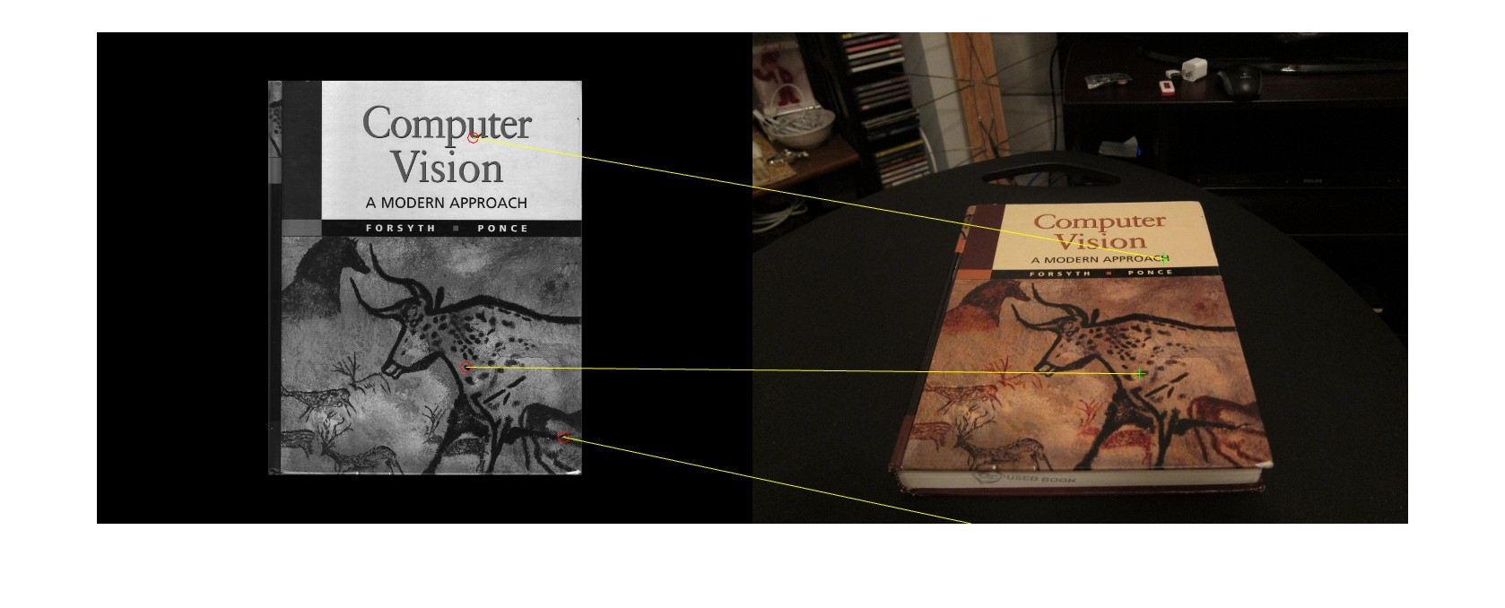

After trying many values for **maxRatios** and keeping the default value of **MatchThreshold** to 10, there were better visualizations. The images were converted into **grayscale** and the **detectFASTFeatures()** method was applied. The best visualization got with **maxRatios = 0.67** and **MatchThreshold** **= 10.**

**Below is the visualization with the above final arrangements where all the points are matched :**

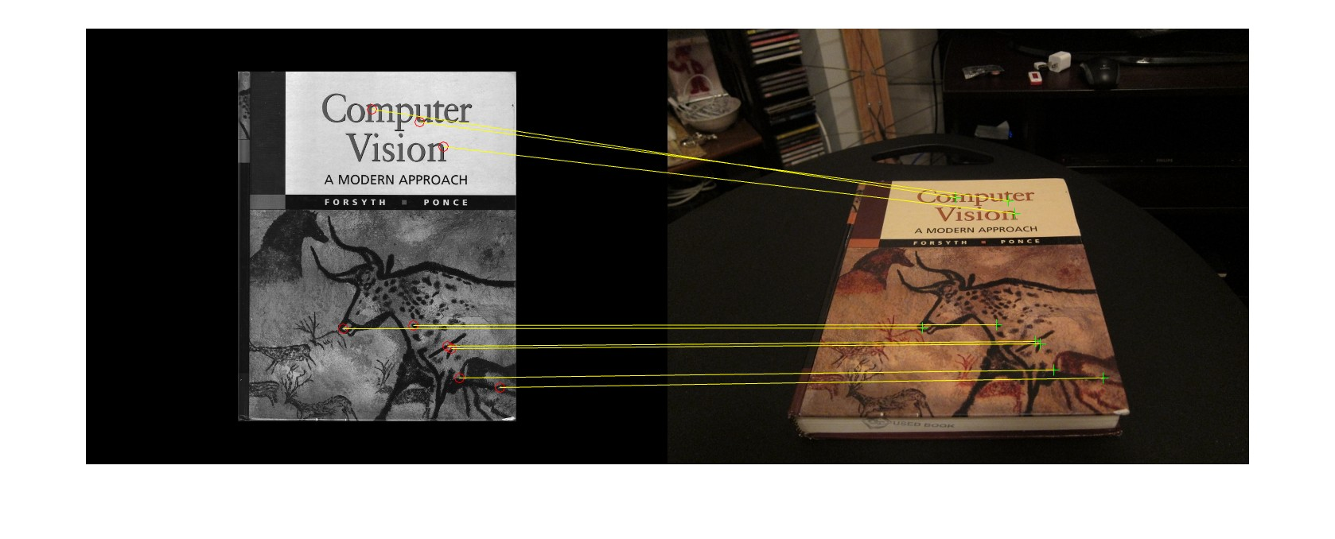

**Task 4.2: BRIEF and Rotations**

In this task, visualizations and histograms generated using **BRIEF** and **SURF** descriptors. The different angles of image are displayed in both descriptor’s visuals. The code for the same is done in “**briefRotTest.m”** file.

**Results of BRIEF descriptor**

Below are the visuals of image on **10**, **100,** **250,** and **350** degrees respectively:

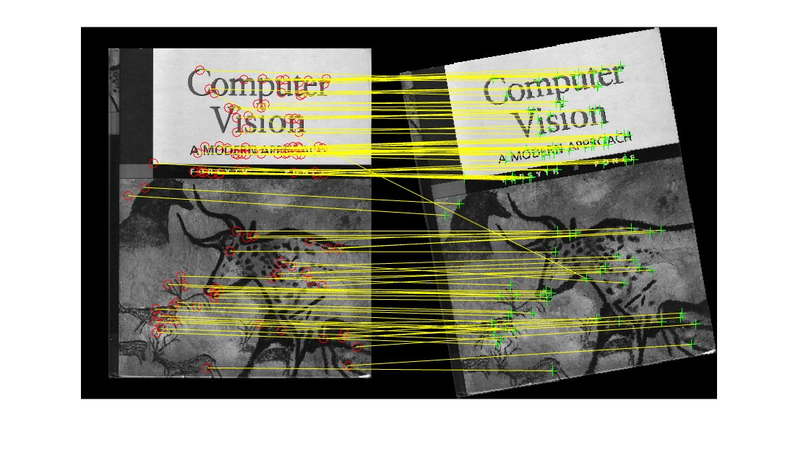

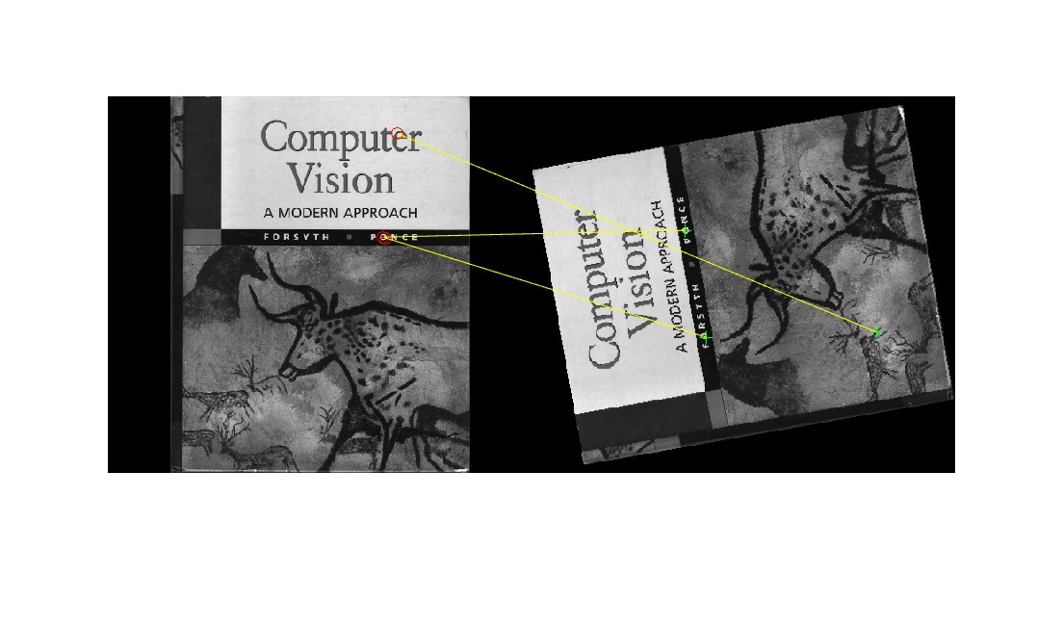

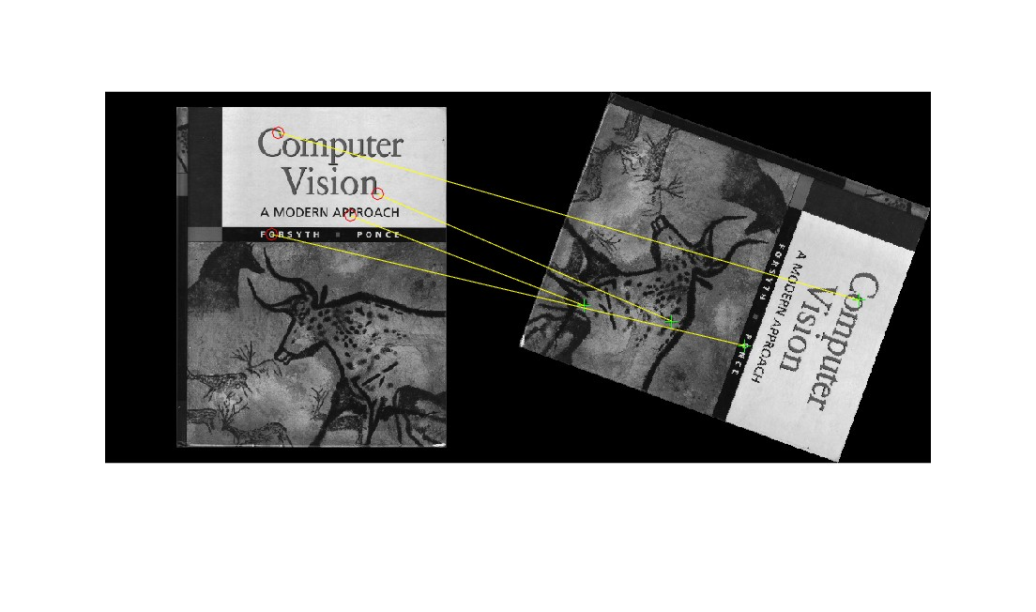

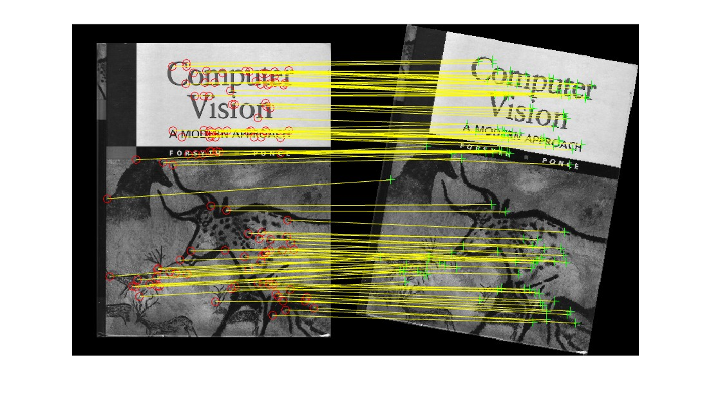

Below is the histogram for **BRIEF** descriptor:

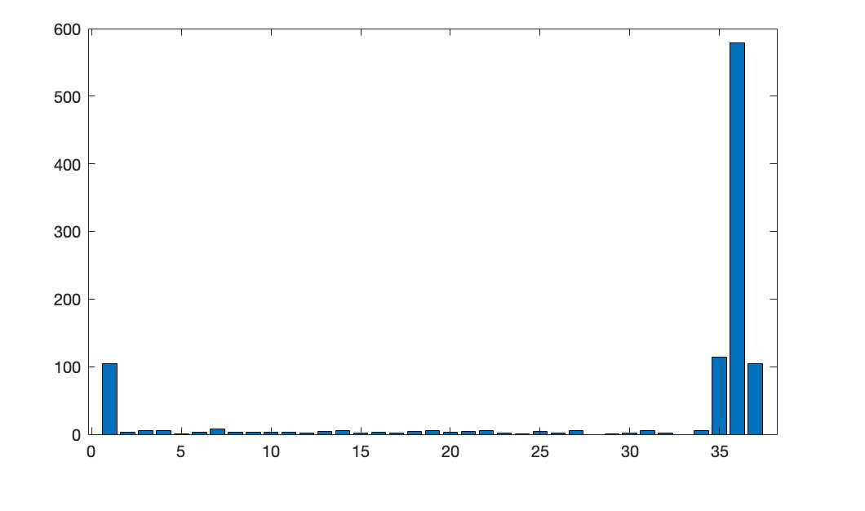

**Results of SURF descriptor**

Below are the visuals of image on **10**, **100,** **250,** and **350** degrees respectively:

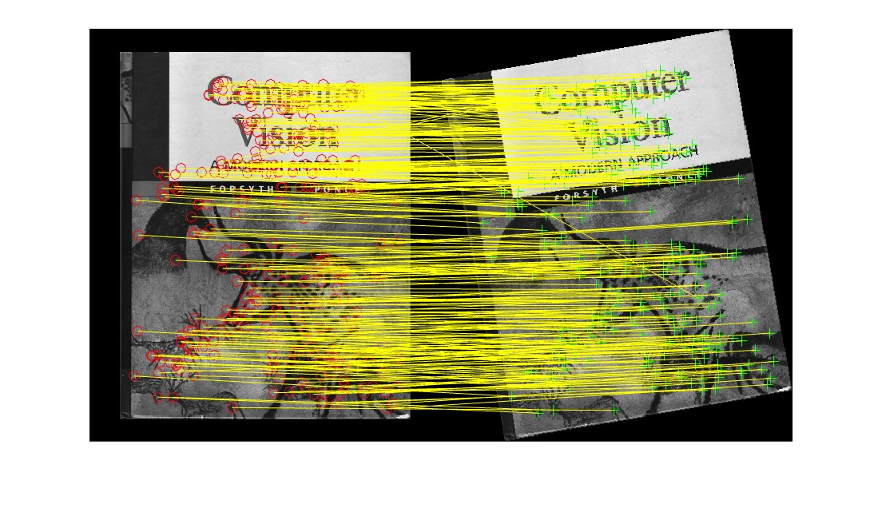

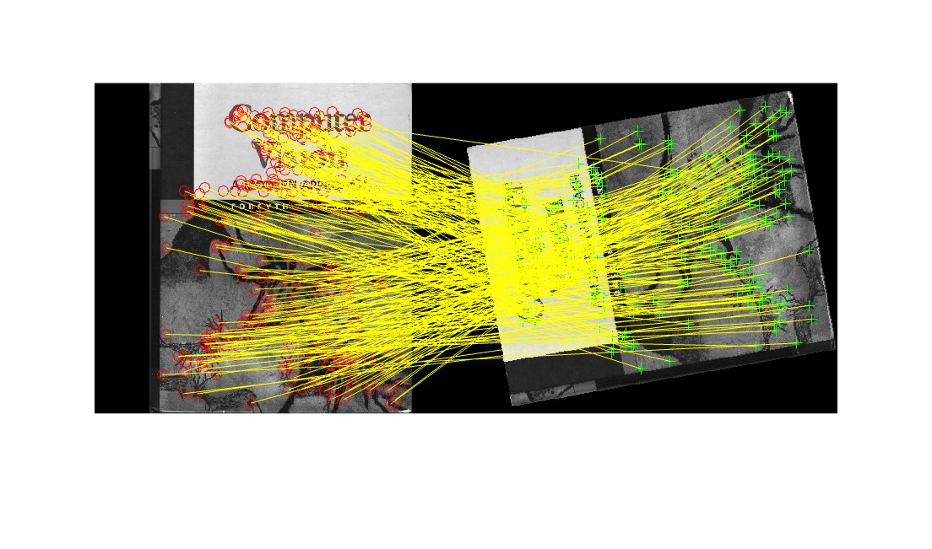

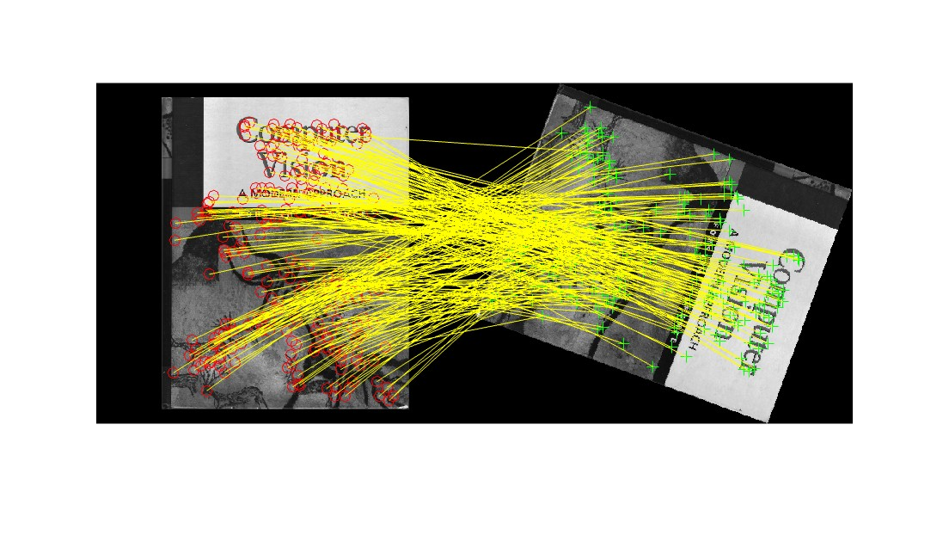

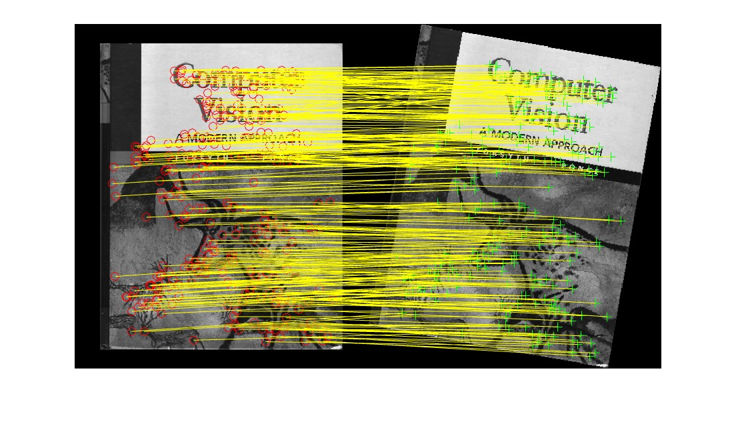

Below is the histogram for **SURF** descriptor:

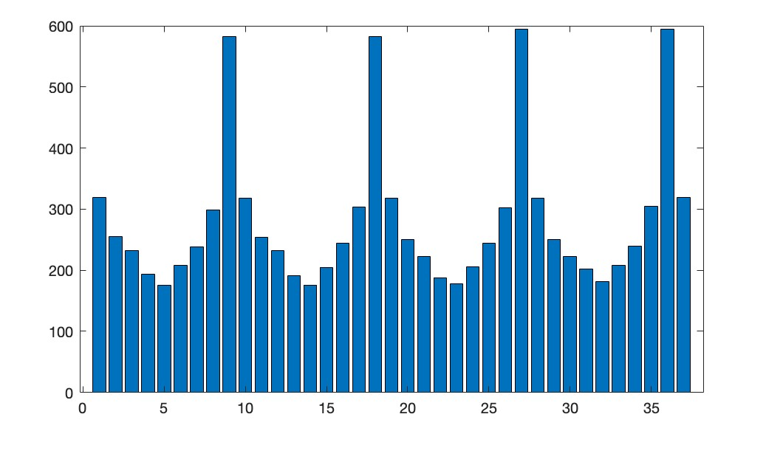

**Behavior of BRIEF descriptor:**

After comparing the results of both the descriptors, it is observed that the BRIEF has detected very less features when the rotation is done. The good number of features are detected small angle like 10 and big angles ranging from 350 to 370 as shown in the histogram. So, there is no pattern that can be identified. Some of the possible reasons for its behavior are :

* BRIEF is sensitive to noise, and it is a simple descriptor that do the intensity comparison between pairs of pixels. So, unlike the SURF, it might not be able to capture complex patterns or variations effectively.
* BRIEF is also sensitive to image rotation, scale, and translation, which means that it might not be as robust as SURF to changes in viewpoint. Thus, if the image contains repetitive or symmetric patterns, it will be hard to detect all the features properly.

**Plot for the SURF:**

SURF worked great for the rotation as shown in the histogram. Here, the plot changed significantly. It detected features for every angle and worked exceptionally well for 90, 190, 280, and 360 degrees which was not the case with BRIEF. Moreover, for every other angle the SURF is working way better than the BRIEF. For example, at 100 and 250 degrees BRIEF barely detected any feature whereas SURF detected about 200- 300 features. The results for 100 and 250 degrees are also added above under the respective descriptor.

**Task 4.3: Homography Computation**

In this task a function “**computeH”** is implemented that estimates the planar homography from a set of matched point pairs. The code for the same is done in “**computeH.m**” script. There is a separate script “**result_H_H_norm.m**” made to test the computeH function and get the visuals. The 10 random points were selected from the cover image and matched with the other image. The computed points from homograpghy and the 10 randomly selected points are displayed below:

**Randomly Selected Points**

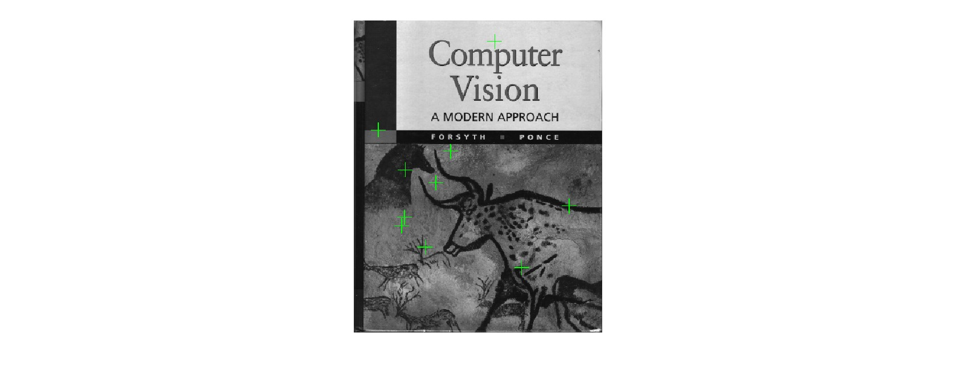

**Homography Computed Points**

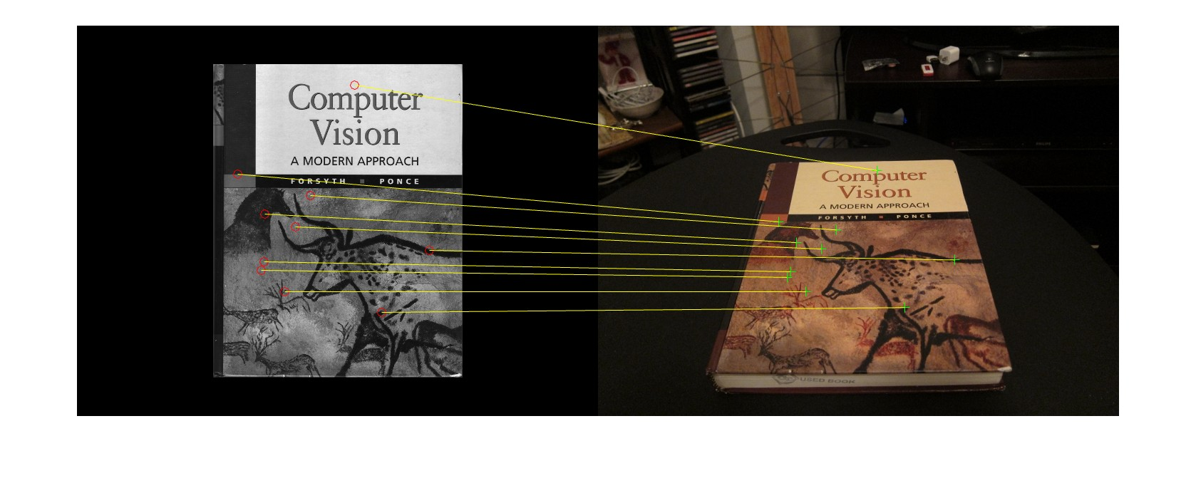

**Task 4.4: Homograpghy Normalization**

In this task, the numerical stability of the solution is improved by normalizing the coordinate data which was done by translating the mean of the points of the origin and scaling the points. Again, for this task 10 random points from cover image were selected and matched. The function “**computeH_norm**” is implemented in the script “**computeH_norm.m**” script. The results and visuals are generated through the “**result_H_H_norm.m**” script. Below are the visuals of the 10 random points selected and the corresponding locations in the second image after the homograpghy transformation:

**Randomly Selected Points**

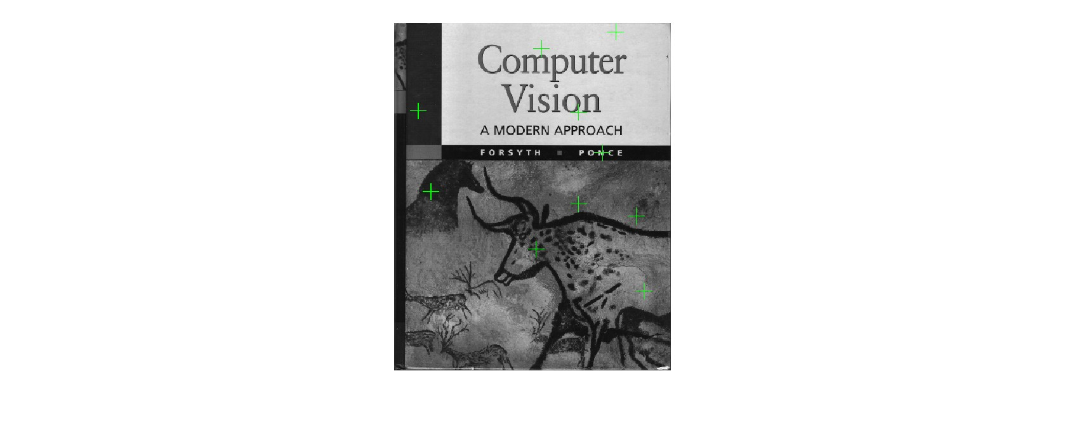

**Homography Normalized Points**

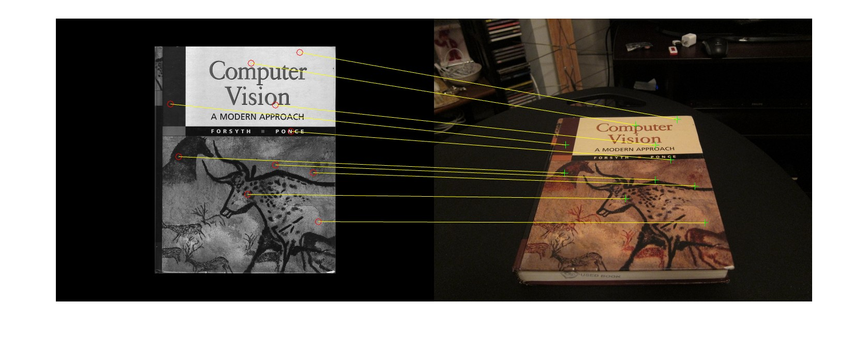

**Task 4.5: RANSAC**

In this task RANSAC algorithm is used to fit model to noisy data. The “**computeH_ransac**” function is implemented in the provided “**computeH_ransac.m**” script. The method is tested, and the visuals are generated through the separate script “**result_RANSAC.m**”, provided in the “**matlab**” folder. Below is the visualized 4 point-pairs that are matched by the RANSAC algorithm:

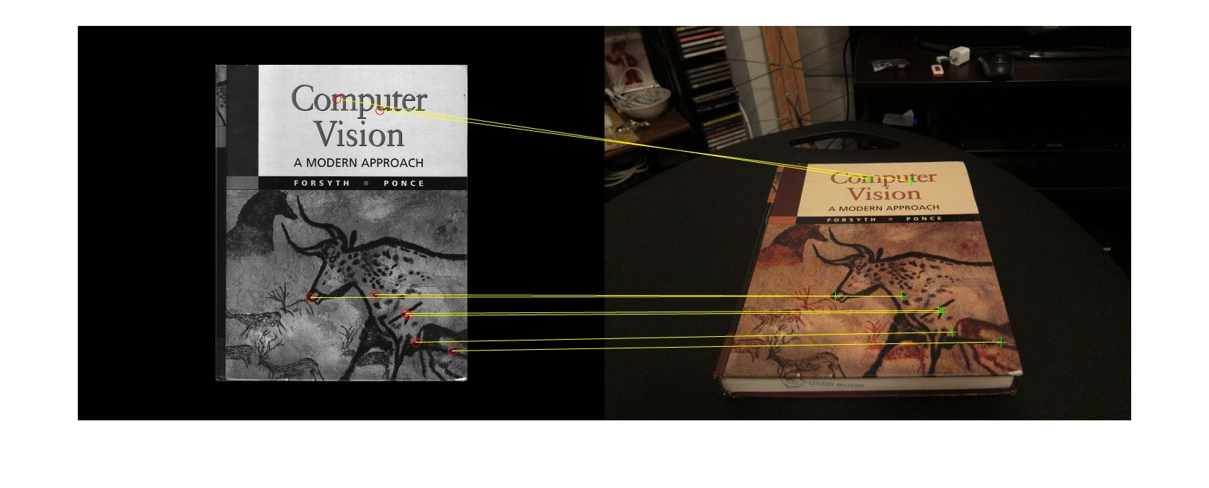

**Task 4.6: HarryPotterizing a Book**

In this task, it is asked to display harry potter cover on the “**cv_desk**”. The **computH_ransac** method is used and the “**max_iter**” value were set to **5000.** The code for the same is done in the provided “**HarryPotterize_auto.m**” script**.** Below is the visualized harry potter cover on the book:

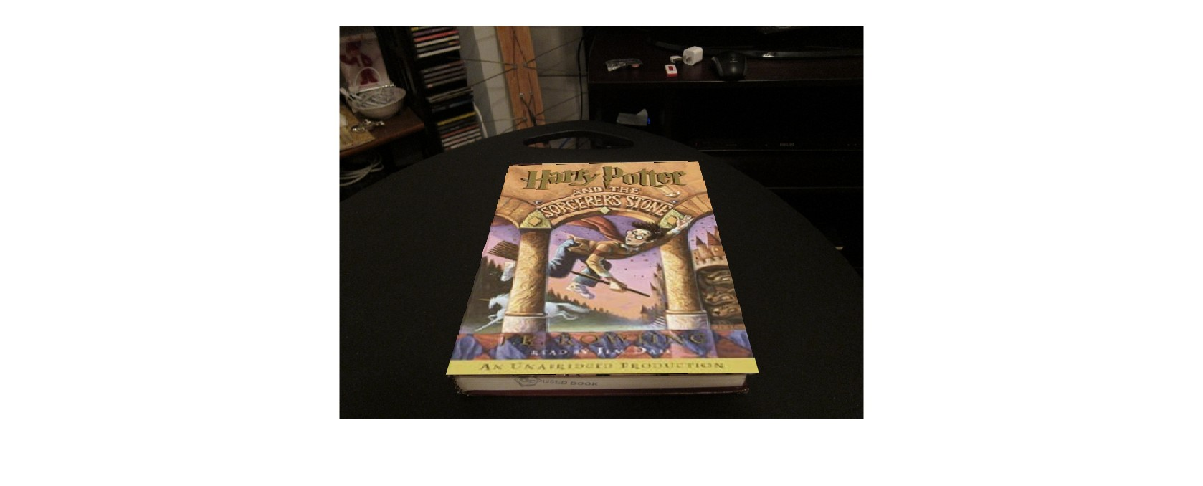

**Task 5.1: Creating your Augmented Reality applixation**

In this task, it is asked to create Augmented Reality application. The code for the same is done in “**ar.m”** script. The video is saved under “**result**” folder by the name “**ar.avi**”. Below are some of the screenshots taken from the video:

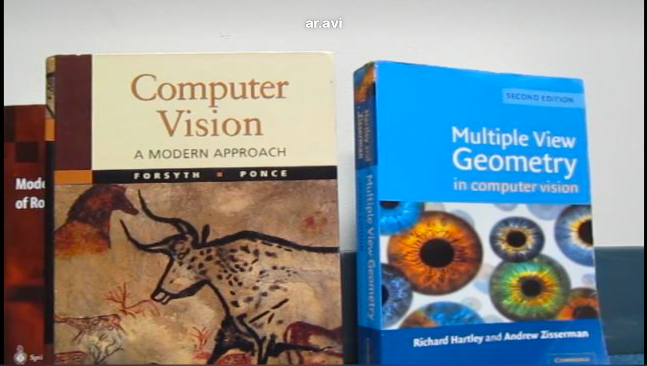

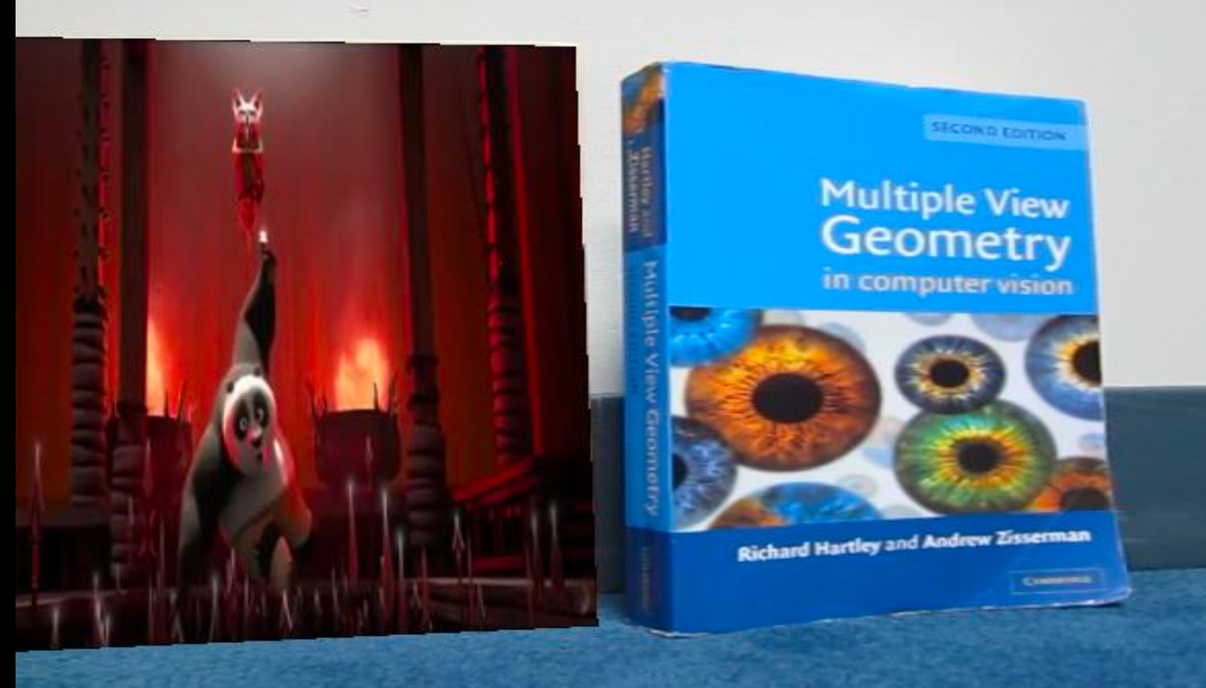

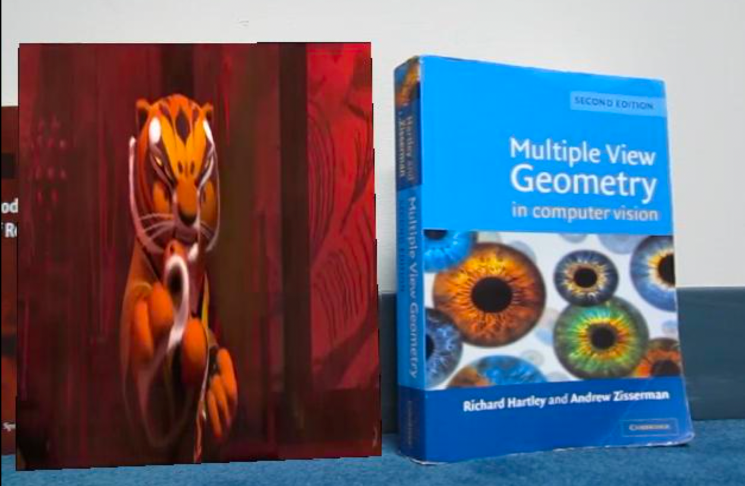

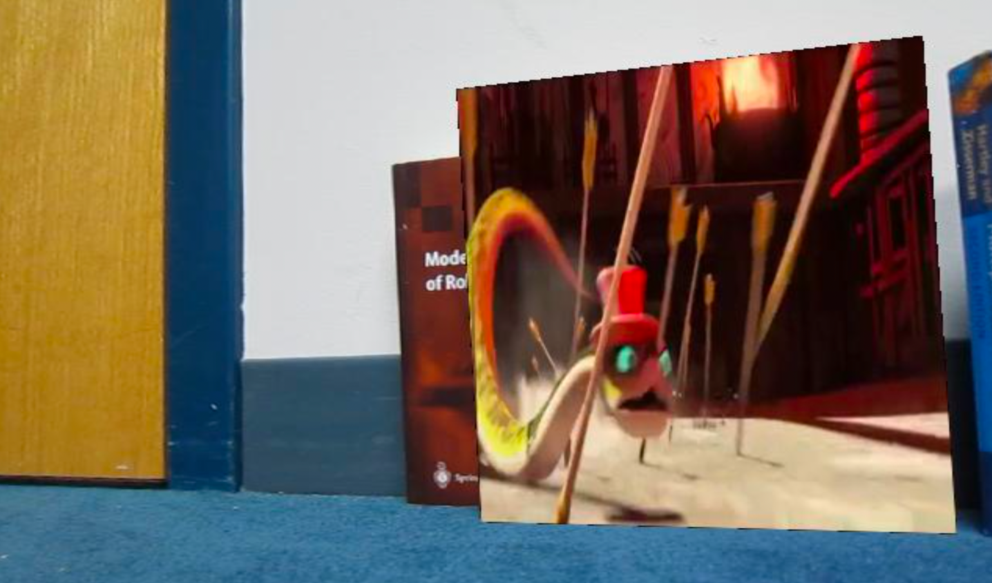

All the scripts are provided in **matlab** folder and all the visuals are provided in **results** folder.